CHAPTER 1

INTRODUCTION

During the last decade, most of the financial and government organizations have extended their online services to their clients. In 2011, 83% of Americans and 85% of Europeans regularly shopped online. Phishing is a criminal technique employing both social engineering and technical subterfuge to steal consumer's personal identity data and financial account credential. Phishing is a form identity theft crime. Phishing websites are fake web pages that are created by malicious people to imitate web pages of real websites. Phisher typically create web pages that are visually very similar to the real web pages in order to scam their victims. An unaware client might be easily deceived by this kind of scam. The Victims of a phishing Web page may expose their bank account, password, credit card number, or other important information to the phishing Web page owners. While phishing is a relatively new Internet crime when compared to other forms e.g., viruses and hacking, a recognizable increase in the number and severity of phishing attacks is reported. According to a recent study, 57 million Internet users have identified the receipt of email linked to phishing, about 1.7 million of them are thought to have yielded to the convincing attacks and tricked them into revealing personal information. Studies by the AntiPhishing Working Group (APWG) have concluded that Phishers are likely to succeed with as much as 5% of all message recipients.

The aim of the phishing website is to steal the victims’ personal information by visiting and surfing a fake webpage that looks like a true one of a legitimate bank or company and asks the victim to enter personal information such as their username, account number, password, credit card number,…,etc. The impact is the break of information security through the compromise of confidential data and the victims may finally suffer losses of money or other kinds of assets. The attackers might also commit identity theft crimes using the victim’s stolen information.

Phishing has a huge negative impact on organizations’ revenues, customer relationships, marketing efforts, and overall corporate image. Phishing attacks may cost companies hundreds of thousands of dollars per attack in fraud-related losses and personnel time. Even worse, costs associated with the damage to brand image and consumer confidence can run in the millions of dollars.

1.2 LITERATURE REVIEW

The following papers have been cited during the literature survey to understand the different applications of computer systems in allied areas of the present project work carried out.

(Prof. S. G. Galande, et al., 2015) have presented Internet of Things Implementation for Wireless Monitoring of Agricultural Parameters [1]. In Asian nation around seventieth of the population earn its resource from agriculture sector. Taking thought to the current state of affairs, during this paper system planned that attempt to develop a wireless system that monitors environmental conditions in agriculture field like temperature, soil pH, soil wet level and humidness beside leaf diseases detection. an efficient implementation for web of Things used for observance regular environmental conditions by means that of low value omnipresent sensing system and result with current all parameters, affected plant disease, its management measures is shipped to our e-mail account.

# (Mark Seelye et al., 2011) have presented Low Cost Colour Sensors for Monitoring Plant Growth in a Laboratory [2]. An automated system for measuring plant leaf colour, as an indicator of plant health status, has been developed for plantlets growing in a modified micro-propagation system. Using a custom built robotic arm, sensors located on a pan and tilt system at the end of the arm monitor plant growth and the ambient growing environment.

(Oliver Schmittmann et al., 2017) have presented A True-Color Sensor and Suitable Evaluation Algorithm for Plant Recognition [3]. the system described in this work is based on free cascadable and programmable true-colour sensors for real-time recognition and identification of individual weed and crop plants. . Initially, databases with reflection properties of plants, natural and artificial backgrounds were created. Crop and weed plants should be recognized by the use of mathematical algorithms and decision models based on these data.

(Zhang Chuanlei et al., 2017) have presented Apple Leaf Disease Identification using Genetic Algorithm and Correlation based feature selection method [3]. In this research, based on image processing techniques and pattern recognition methods, an apple leaf disease recognition method was proposed. A color transformation structure for the input RGB (Red, Green and Blue) image was designed firstly and then RGB model was converted to HSI (Hue, Saturation and Intensity), YUV and gray models. The background was removed and then the disease spot image was segmented with region growing algorithm (RGA). Finally, the diseases were recognized by SVM classifier.

(Yun Shi et al., 2015) have presented Internet of Things Application to Monitoring Plant Diseases and Insect Pests [4]. This paper introduces the concept of internet of things (IOT) technology to percept information, and discusses the role of the IOT technology in agricultural disease and insect pest control, which includes agricultural disease and insect pest monitoring system, collecting disease and insect pest information using sensor nodes, data processing and mining, etc.

(K.Lakshmi, S.Gayatri, 2017) have presented Implementation of IoT with Image Processing in plant growth monitoring system [5]. This work combines Image Processing and IoT to monitor the plant and to collect the environmental factors such as humidity and temperature. In image processing, a recognition system capable of identifying plants by using the images of their leaves has been developed and with the help of the images use of pesticides can be controlled.

(Murali Krishnan, Jabert.G, 2013) have presented Pest Control in Agricultural Plantations Using Image Processing [6]. Mono cropped Plantations are under constant threat of pest and disease incidence because it favours the build up of pest population. To cope with these problems, an automatic pest detection algorithm using image processing techniques in MATLAB has been proposed in this paper. Image acquisition devices are used to acquire images of plantations at regular intervals. These images are then subjected to pre-processing, transformation and clustering.

([Sushma R. Huddar](https://ieeexplore.ieee.org/search/searchresult.jsp?searchWithin=%22Authors%22:.QT.Sushma%20R.%20Huddar.QT.&newsearch=true) et al., 2012) have presented Novel algorithm for segmentation and automatic identification of pests on plants using image processing [7]. The proposed methodology involves reduced computational complexity and aims at pest detection not only in a greenhouse environment but also in a farm environment as well. The whitefly, a bio-aggressor which poses a threat to a multitude of crops, was chosen as the pest of interest in this paper. The algorithm was tested for several whiteflies affecting different leaves and an accuracy of 96% of whitefly detection was achieved. The algorithm was developed and implemented using MATLAB programming language on MATLAB 7.1 build 2011a.

(Dr. S. Gavaskar Dr. A. Sumithra 2017) have presented Design and Development of Pest Monitoring System for Implementing Precision Agriculture using IOT [8]. India’s most of the farmer grow sugarcane but did not get yielding due to bugs and larvae in sugarcane. To avoid this situation, the proposed design has been developed with acoustic sensor and pir sensor. In this proposed design system used arduino for monitoring the noise and temperature. So finding the problem can be simplified and solved easily

(Nimish Gopal, 2016) have presented Micro-Controller Based Auto-irrigation And Pest Detection Using Image Processing [9]. This study refers to a collaboration of automation and electronics to suggest an auto irrigation system inclusive of a pest detector. The technique of image analysis is extensively applied to agriculture science to provide maximum protection to crops which can ultimately lead to better crop management and production. This study extends the implementation of different image processing techniques to detect and extract pests by establishing an automated detection and monitoring in order to minimize human efforts and errors.

(Sai Vivek et al., 2017) have presented Arduino Based Pest Control Using Real Time Environmental Monitoring Sensors [10]. This paper strives to develop a robot capable of performing operation of dispensing pest control agents, obstacle avoidance for self-guidance on the field without any user interference and create a sterile environment for the optimum growth of the crops in a real time monitored closed environment.

1.3 MOTIVATION AND PROBLEM STATEMENT

Plant diseases seriously affect the normal growth of plants, the yield and quality of agricultural products. In recent years, with the dramatic changes in climate, the natural environment of the plant growth has been damaged by pollution, frequent natural disasters, as well as the development of agricultural production. From the literature survey presented above, it is observed that the work on plant disease detection using IoT reported in the literature is scarce. In the present work, this issue is addressed using sensor based technology. This being the motivation, the problem entitled“Leaf Disease Detection using IoT”is proposed to assist the farmers technologically. In the proposed work, focus has been on early detection of disease infection.

1.4 PROPOSED METHODOLOGY

The proposed system consists of two types of sensors for collecting different types of data, regarding the leaves. The data collected from the leaves consists of current environmental factors like temperature, humidity and color. The Changes that a plant undergoes are captured by the temperature and humidity sensors and analyzed with the Arduino software. The data’s collected from temperature and humidity sensors are given to Arduino UNO kit from which the information is communicated to the farmers. The system makes use of WiFi shield in order to send the data from the host system to the cloud platform for analysis. The cloud platform that we have used in this project is the www.thingspeak.com. The collected data in the cloud platform is then compared with the dataset in order to detect whether the leaf under consideration is diseased or healthy.

i) Data acquisition

ii) Temperature sensor

iii) Humidity sensor

iv) colour sensor

v) Aurdino

vi) Cloud platform

i)Data acquisition: Here we take samples of different leaves as the input.These leaves are then sensed by the sensors to determine different parameters that affect the appearance of the leaves so that they can be defied whether they are healthy or diseased.

ii) Temperature sensors: The DHT11 is a basic, ultra low-cost digital temperature sensor. It uses a capacitive humidity sensor and a thermistor to measure the surrounding air, and spits out a digital signal on the data pin (no analog input pins needed). Its fairly simple to use, but requires careful timing to grab data.

iii)Humidity sensor: The DHT11 is a basic, ultra low-cost digitalhumidity sensor. It uses a capacitive humidity sensor and a thermistor to measure the surrounding air, and spits out a digital signal on the data pin (no analog input pins needed). Its fairly simple to use, but requires careful timing to grab data.

iv)Colour sensor: The TCS3200 is a programmable color light-to-frequency converter/sensor. The sensor is a single monolithic CMOS integrated circuit that combines a configurable silicon photodiode and a current-to-frequency converter. The output is a square wave (50% duty cycle) with frequency directly proportional to light intensity (irradiance).

v) Aurdino: The Arduino UNO is a widely used open-source microcontroller board based on the [ATmega328P](https://en.wikipedia.org/wiki/ATmega328P) microcontroller and developed by [Arduino.cc](https://en.wikipedia.org/wiki/Arduino) The board is equipped with sets of digital and analog input/output (I/O) pins that may be interfaced to various expansion boards (shields) and other circuits.[]](https://en.wikipedia.org/wiki/Arduino_Uno#cite_note-Makerspace-1) The board features 14 Digital pins and 6 Analog pins. It is programmable with the [Arduino IDE](https://en.wikipedia.org/wiki/Arduino#software)(Integrated Development Environment) via a type B USB cable.[[4]](https://en.wikipedia.org/wiki/Arduino_Uno#cite_note-priceton-4) It can be powered by a USB cable or by an external 9 volt battery, though it accepts voltages between 7 and 20 volts.

Vi) Cloud platform: Here we make use of “ThingSpeak” cloud platform to send the sensed data to the cloud. This data sent is plotted against the graph to view the change in the temperature ,Humidity and the colour. Depending on the data that is plotted against the graph we see if the values fall into the same range. If they do so then the leaf is healthy or else it is diseased.

All these components are put together as one system to determine if the leaves are healthy or if they are diseased.

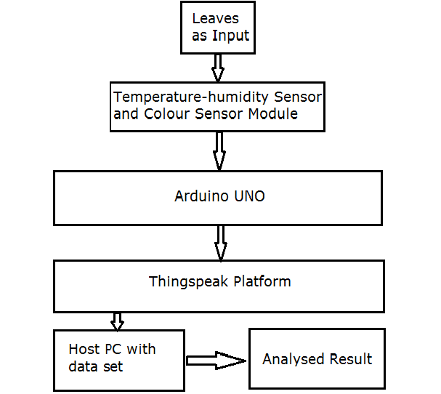

Figure 1.2: Block Diagram

1.5 OBJECTIVE AND SCOPE

The overall goal of this project is to develop an automated system to detect the diseases in the plant leaf. The following objectives are being fulfilled in the project work

1. Identification of plant disease using temperature sensor.
2. Identification of plant disease using humdity sensor.
3. .Identification of the plant diseases using colour sensor.

This system will be detecting the diseases in the plant leaf. This system will be designed to detect the disease in the leaves by providing a system with tools that assist to collect the required parameters. We will have a dataset that consists of standard values of the parameters used for some of the leaves taken into consideration. The collected sample values from the system are compared with the values in the dataset. After comparison, the result will be inferred whether the leaf is healthy or diseased.

1.6 Organization of the report

This project is developed to meet three objectives. Each of these objectives are presented as three different chapters.

The three objectives are as follows:

1. Identification of plant disease using temperature sensor.
2. Identification of plant disease using humdity sensor.
3. .Identification of the plant diseases using colour sensor.

The first objective of the project is met in the chapter 2 that deals with sensing the temperature of the leaves to determine if the leaf under consideration is either healthy or diseased.

The second objective of the project is met in the chapter 3 that deals with sensing the humidity of the leaves to determine if the leaf under consideration is either healthy or diseased. As humidity is considered as another parameter to determine the result.

The third objective of the project is met in the chapter 4 that deals with sensing the colour of the leaves to determine if the leaf under consideration is either healthy or diseased. As colour is considered as another parameter to determine the result and classify them.

CHAPTER 2

IDENTIFICATION OF PLANT DISEASE USING TEMPERATURE SENSOR

In the previous chapter, after defining the problem statement we have mentioned three objectives to be accomplished. The chapter deals with the first objective that is the methodology of sensing the temperature of the leaves which is used as one of the parameters to decide whether the leaf is healthy or diseased.

* 1. INTRODUCTION

These pigments in leaves are responsible for the vivid color changes in the fall. Temperature, sunlight and soil moisture all play a role in how the leaves will look in the fall. Abundant sunlight and low temperatures after the abscission layer forms cause the chlorophyll to be destroyed more rapidly

This module integrates DHT11 sensor and other required components on a small PCB.  The DHT11 sensor includes an NTC temperature measurement component and a high-performance 8-bit microcontroller inside and provides calibrated digital signal output.  It has high reliability and excellent long-term stability.

The single-wire serial interface makes system integration quick and easy. Its small size, low power consumption and up-to-20 meter signal transmission making it the best choice for various applications, including those most demanding ones. The component is 3-pin single row pin package. It is convenient to connect and special packages can be provided according to users’ request.

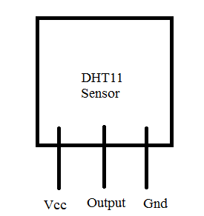

Figure 2.1: Pin diagram of DHT11 Sensor

The module is actually a PCB that has DHT11 component soldered with a few components, and it is a 3-wire module:

1.    VCC connected to +3.3V~5V  
2.    DATA connected to the microcontroller IO port  
3.    GND connected to ground

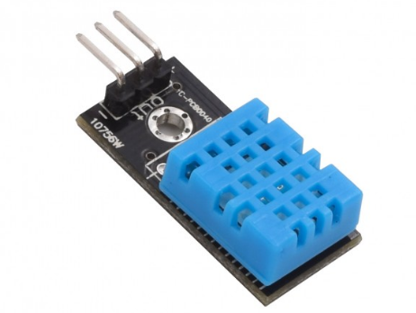

Figure 2.2: DHT11 Sensor

2.2 TECHNICAL SPECIFICATIONS：

* Power Supply： 3.3~5.5V DC
* Output： 4 pin single row
* Measurement Range： Temperature  0~50℃
* Accuracy： Temperature +-2℃
* Resolution：Temperature  1℃
* Interchange-ability： Fully Interchangeable
* Long-Term Stability： <±1%RH/year

2.3 ALGORITHM

Algorithm: I

Input: Data acquisition

Output: Diseased or Healthy

Description: Given temperature range for the leaf to be healthy is 15-300 C

Step 1: Start

Step 2: Input leaf for data acquisition.

Step 3: Sense the temperature of the leaf using the DHT11 sensor.

Step 4: if (min temperature < temperature< max temperature)

Display “Leaf is Healthy”

else

Display “Leaf is Diseased”

Step 5: Display the output.

Step 6: Stop

2.4 METHODOLOGY

The DHT11 sensor has 3 pins- Vcc is connected to the 5V power supply pin of the Arduino UNO board and the ground pin is connected to the ground pin of the Arduino UNO and the output pin is connected to one of the digital output pin of the Arduino UNO.

The DHT11 sensor senses the temperature of the leaf under consideration. The parameters that are collected from the sensor are sent to the cloud platform through the wifi shield connected to the Arduino UNO board. The data which is recorded is then plotted on to the graph for analysis in the cloud platform.

We initially record the range of the temperature of a healthy leaf. Later, if the temperature of the leaf under consideration does not fall into that range, then the leaf is said to be diseased.

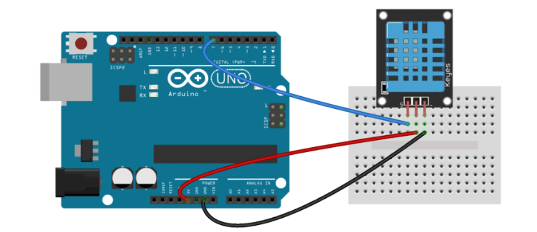

Figure 2.3: Configuration of DHT11 with Arduino UNO

2.5 RESULTS

|  |  |
| --- | --- |
| Diseased Leaves | Healthy Leaves |
| (a) | (b) |
| (c) | (d) |

Figure 2.4: Some of the sample leaves considered.

Table 2.1: Result analysis with temperature as a parameter

|  |  |  |  |
| --- | --- | --- | --- |
| Leaf | Minimum Temperature in Degree Celsius | Maximum Temperature in Degree Celsius | Obtained Temperature in Degree Celsius |
| 1 | 32 | 35 | 46 |
| 2 | 33 | 34 | 27 |
| 3 | 33 | 35 | 23 |
| 4 | 32 | 36 | 21 |
| 5 | 31 | 35 | 39 |
| 6 | 30 | 35 | 22 |
| 7 | 32 | 34 | 25 |
| 8 | 29 | 35 | 40 |
| 9 | 28 | 38 | 42 |

As in the table mentioned above we have considered certain values for the healthy leaves. If the values that we get from the leaves under consideration fall within that range then the leaves are healthy, if not then the leaves are diseased. We have collected range of values for considered parameters for 9 different leaves which are healthy as well as diseased. Thus considering temperature values we infer that all the leaves are diseased in the above table 2.1 as their temperature values do not fall into given range.

2.6 SUMMARY OF THE WORK

In this chapter we have considered the temperature as parameters to distinguish healthy and diseased leaves. If a leaf is affected by any kind of disease then moisture content in the leaf changes because of which temperature is also affected. In order to determine the difference in the humidity of the leaves, we have used DHT11 temperature sensor. It senses the temperature values of the leaf under consideration and it is compared with the values in the dataset to determine the quality of the leaf.

CHAPTER 3

IDENTIFICATION OF PLANT DISEASE USING HUMIDITY SENSOR

In the chapter 1, after defining the problem statement we have mentioned three objectives to be accomplished. The chapter deals with the second objective that is the methodology of sensing the humidity of the leaves which is used as one of the parameters to decide whether the leaf is healthy or diseased.

3.1 INTRODUCTION

These pigments in leaves are responsible for the vivid color changes in the fall. Temperature, sunlight and soil moisture all play a role in how the leaves will look in the fall. Abundant sunlight and low temperatures after the abscission layer forms cause the chlorophyll to be destroyed more rapidly

This module integrates DHT11 sensor and other required components on a small PCB.  The DHT11 sensor includes a resistive-type humidity measurement component and a high-performance 8-bit microcontroller inside and provides calibrated digital signal output.  It has high reliability and excellent long-term stability.

Each DHT11 is strictly calibrated in the laboratory that is extremely accurate on humidity calibration. The calibration coefficients are stored as programmes in the OTP memory, which are used by the sensor’s internal signal detecting process.

The single-wire serial interface makes system integration quick and easy. Its small size, low power consumption and up-to-20 meter signal transmission making it the best choice for various applications, including those most demanding ones. The component is 3-pin single row pin package. It is convenient to connect and special packages can be provided according to users’ request.



Figure 3.1: Pin diagram of DHT11 Sensor

The module is actually a PCB that has DHT11 component soldered with a few components, and it is a 3-wire module:

1.    VCC connected to +3.3V~5V  
2.    DATA connected to the microcontroller IO port  
3.    GND connected to ground



Figure 3.2: DHT11 Sensor

3.2 TECHNICAL SPECIFICATIONS：

* Power Supply： 3.3~5.5V DC
* Output： 4 pin single row
* Measurement Range： Humidity 20-90%RH
* Accuracy： Humidity +-5%RH
* Resolution： Humidity  1%RHInterchange-ability： Fully Interchangeable
* Long-Term Stability： <±1%RH/year

3.3 ALGORITHM

Algorithm: I

Input: Data acquisition

Output: Diseased or Healthy

Description: Given humidity range for the leaf to be healthy is 15-300 C

Step 1: Start

Step 2: Input leaf for data acquisition.

Step 3: Sense the humidity of the leaf using the DHT11 sensor.

Step 4: if (min humidity < humidity< max humidity)

Display “Leaf is Healthy”

else

Display “Leaf is Diseased”

Step 5: Display the output.

Step 6: Stop

3.4 METHODOLOGY

The DHT11 sensor has 3 pins- Vcc is connected to the 5V power supply pin of the Arduino UNO board and the ground pin is connected to the ground pin of the Arduino UNO and the output pin is connected to one of the digital output pin of the Arduino UNO.

The DHT11 sensor senses the humidity of the leaf under consideration. The parameters that are collected from the sensor are sent to the cloud platform through the wifi shield connected to the Arduino UNO board. The data which is recorded is then plotted on to the graph for analysis in the cloud platform.

We initially record the range of the humidity of a healthy leaf. Later, if the humidity of the leaf under consideration does not fall into that range, then the leaf is said to be diseased.



Figure 3.3: Configuration of DHT11 with Arduino UNO

3.5 RESULT

|  |  |
| --- | --- |
| Diseased Leaves | Healthy Leaves |
| (a) | (b) |
| (c) | (d) |

Figure 3.4: Some of the sample leaves considered.

Table 3.1: Result analysis with Humidity as a parameter

|  |  |  |  |
| --- | --- | --- | --- |
| Leaf | Minimum Humidity value | Maximum Humidity value | Obtained Humidity value |
| 1 | 29 | 32 | 42 |
| 2 | 31 | 33 | 45 |
| 3 | 28 | 33 | 47 |
| 4 | 38 | 42 | 42 |
| 5 | 30 | 32 | 48 |
| 6 | 28 | 32 | 48 |
| 7 | 30 | 33 | 42 |
| 8 | 29 | 24 | 49 |
| 9 | 28 | 35 | 42 |

As in the table mentioned above we have considered certain values for the healthy leaves. If the values that we get from the leaves under consideration fall within that range then the leaves are healthy, if not then the leaves are diseased. We have collected range of values for considered parameters for 9 different leaves which are healthy as well as diseased. Thus considering humidity values we infer that all the leaves are diseased in the above table 3.1 as their humidity values do not fall into given range.

3.6 SUMMARY OF THE WORK

In this chapter we have considered the humidity as parameters to distinguish healthy and diseased leaves. If a leaf is affected by any kind of disease then moisture content in the leaf changes because of which temperature is also affected. In order to determine the difference in the humidity of the leaves, we have used DHT11 humidity sensor. It senses the humidity values of the leaf under consideration and it is compared with the values in the dataset to determine the quality of the leaf.

CHAPTER 4

IDENTIFICATION OF PLANT DISEASE USING COLOR SENSOR

The thierd objective mentioned in the Chapter 1 is being covered in this chapter; it deals with the methodology of sensing the colour of the leaves which is used as one of the parameters to decide whether the leaf is healthy or diseased.

* 1. INTRODUCTION

Changes in the color of plant tissue are a common symptom of plant disease. Often these color changes are brought about by the [yellowing](https://en.wikipedia.org/wiki/Zucchini_yellow_mosaic_virus) of normal green tissue due to the destruction of [chlorophyll](https://en.wikipedia.org/wiki/Chlorophyll) or a failure to form chlorophyll. Such repression of leaf color may be complete or partial. When color repression is complete, it is known as albication. However, the more common, partial repression is referred to as [chlorosis](https://en.wikipedia.org/wiki/Chlorosis).

Patches of green tissue alternating with chlorotic areas are described as a [mosaic](https://en.wikipedia.org/wiki/Mosaic_virus). Mosaic is a symptom caused by many viruses. Based on the intensity and the pattern of discoloration, mosaics are termed differently. Irregular patches of distinct light and dark areas are known as [mottling](https://en.wikipedia.org/wiki/Mottle). Streaking and [ring spots](https://en.wikipedia.org/wiki/Turf_necrotic_ring_spot) are still other distinct types of discolorations. Ring spots are circular masses of chlorosis with a green center. Vein clearing and vein banding are yet other common color changes on leaves. Chlorophyll may also develop in tissues normally devoid of it. Thus usually white or colored tissue becomes green in color. This is called as [virescence](https://en.wikipedia.org/wiki/Virescence). [Anthocyanescence](https://en.wikipedia.org/wiki/Anthocyanin) is due to the overdevelopment of anthocyanin and result in the development of a purplish coloration.

The TCS3200 is programmable colour light-to-frequency converters that combine configurable silicon photodiodes and a current-to-frequency converter on a single monolithic CMOS integrated circuit. The output is a square wave (50% duty cycle) with frequency directly proportional to light intensity (irradiance). The full-scale output frequency can be scaled by one of three preset values via two control input pins.

Digital inputs and digital output allow direct interface to a microcontroller or other logic circuitry. Output enable (OE) places the output in the high-impedance state for multiple-unit sharing of a microcontroller input line.

In the TCS3200, the light-to-frequency converter reads an 8 x 8 array of photodiodes. Sixteen photodiodes have blue filters, 16 photodiodes have green filters, 16 photodiodes have red filters, and 16 photodiodes are clear with no filters.

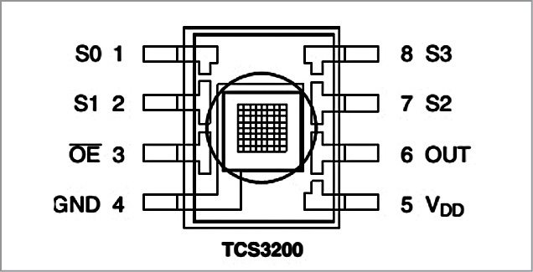

Figure 4.1: Pin diagram of TCS3200 RGB colour sensor

TCS3200 module has ten pins. This module consists of programmable color light-to-frequency converters that combine configurable silicon photodiodes and current-to-frequency converter on a single monolithic CMOS integrated circuit. Output is square-wave (50 per cent duty cycle) with frequency directly proportional to light intensity (irradiance).

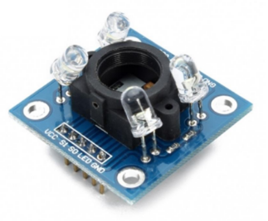

Figure 4.2: TCS3200 RGB Color sensor

4.2 TECHNICAL SPECIFICATIONS

* High-Resolution Conversion of Light Intensity to Frequency
* Programmable Color and Full-Scale Output Frequency
* Communicates Directly With a Microcontroller
* Single-Supply Operation (2.7 V to 5.5 V)
* Power Down Feature
* Nonlinearity Error Typically 0.2% at 50 kHz
* Stable 200 ppm/°C Temperature Coefficient
* Low-Profile Lead (Pb) Free and RoHS Compliant Surface-Mount Package

4.3 ALGORITHM

Algorithm: To detect the disease in the leaf using colour as a parameter.

Input: Data acquisition

Output: Diseased or Healthy

Description: Given colour range (RGB value) for the leaf to be healthy is 15-300 C

Step 1: Start

Step 2: Input leaf for data acquisition.

Step 3: Sense the colour of the leaf using the DHT11 sensor.

Step 4: if (min RGB value < RGB value< max RGB value)

Display “Leaf is Healthy”

else

Display “Leaf is Diseased”

Step 5: Display the output.

Step 6: Stop

3.4 METHODOLOGY

The TCS3200 RGB color sensor has 10 pins. One of the Vcc pin is connected to the 5V power supply pin of Arduino UNO, ground pin is connected to the ground pin of Arduino UNO and S0, S1, S2, S3 and output pin are connected to the digital output pins of Arduino UNO.

The sensor senses the color of the leaf under consideration which is another parameter that is being used to determine whether the leaf is either diseased or healthy. The sensor records values for, “RED”, “Green” and “Blue” value of the leaf.

These values that are recorded for the leaf are then sent to the cloud platform by the arduino board through the ESP8266 Wi-Fi Shield for analysis. These values are then plotted in the graphs. Later the obtained values of RGB are compared with the threshold value in dataset to determin whether the leaf is healthy or diseased.

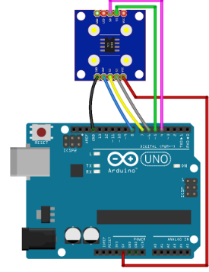

Figure 4.3: Configuration of TCS3200 sensor with Arduino UNO

4.5 RESULTS

|  |  |  |  |  |  |  |  |
| --- | --- | --- | --- | --- | --- | --- | --- |
| |  |  | | --- | --- | | Diseased Leaves | Healthy Leaves | | (a) | (b) | | (c) | (d) |   Figure 4.4: Some of the sample leaves considered.  Table 4.1: Result analysis for colour parameter |  |

|  |  |  |  |  |  |  |  |  |  |
| --- | --- | --- | --- | --- | --- | --- | --- | --- | --- |
| Leaf | Minimum Colour value | | | Maximum Colour value | | | Obtained Colour value | | |
| Red Green Blue | | | Red Green Blue | | | Red Green Blue | | |
| 1 | 93 | 111 | 68 | 104 | 115 | 80 | 131 | 124 | 102 |
| 2 | 76 | 94 | 68 | 82 | 119 | 68 | 152 | 141 | 108 |
| 3 | 109 | 115 | 91 | 114 | 124 | 97 | 98 | 111 | 80 |
| 4 | 125 | 136 | 102 | 131 | 141 | 108 | 185 | 162 | 142 |
| 5 | 82 | 98 | 74 | 87 | 124 | 74 | 125 | 128 | 102 |
| 6 | 93 | 107 | 85 | 93 | 124 | 91 | 104 | 111 | 85 |
| 7 | 82 | 94 | 68 | 87 | 98 | 68 | 114 | 124 | 87 |
| 8 | 85 | 100 | 70 | 88 | 130 | 78 | 120 | 144 | 100 |
| 9 | 80 | 115 | 102 | 83 | 120 | 105 | 99 | 135 | 120 |

|  |  |  |  |
| --- | --- | --- | --- |
| As in the table mentioned above we have considered certain values for the healthy leaves. If the values that we get from the leaves under consideration fall within that range then the leaves are healthy, if not then the leaves are diseased. We have collected range of values for considered parameters for 9 different leaves which are healthy as well as diseased. Thus considering RGB values we infer that all the leaves are diseased in the above table 4.1 as their RGB values do not fall into given range.  4.6 SUMMARY OF THE WORK  In this chapter we have considered the colour as parameters to distinguish healthy and diseased leaves. If a leaf is affected by any kind of disease then it can be easily identified by its colour as its appearance changes. In order to determine the difference in the colour of the leaves, we have used TCS3200 colour sensor. It senses the RGB values of the leaf under consideration and it is compared with the values in the dataset to determine the quality of the leaf. | | |  |
|  |  |
|  |  |

CONCLUSION AND FUTURE SCOPE

LIMITATIONS OF THE PROPOSED MODEL

The proposed system is limited to only detect whether the leaf under consideration is healthy or diseased. This can be further carried out for even recognizing the kind of diseases in the leaves and classification of those diseases.

We have limited our work to only to the temperature, humidity and color parameters of the leaves. This can be further enhanced by applying the image processing concepts.

The other limitation is that the determined values for the considered parameters are not precise. We have taken the range of values for those parameters and the range may vary based on the climatic conditions.

CONCLUSION

In this project, a system is developed to determine to the quality of the leaves. The proposed method uses the sensor devices to detect the parameters like temperature, humidity and color of the leaves, which are then compared with the dataset to check whether the collected values falls in to the range specified in the dataset. The proposed model can be used in different areas by farmers, industrialists, botanists, food engineers and physicians.

FUTURE SCOPE

The avenues for further work in this area is the point to use the image processing techniques along with the proposed system to make it more efficient and also accurate to determine the values and to define whether the leaves are diseased or healthy.

To build an extended version of the system, we can use the image processing technique that detect the kind of the disease the leaf is affected with and classifies the different diseases among the leaves. Here we can build an automated system so that it is useful for the large scale production and also helps in early detection of the diseases that helps the clients for the better performance and enhances the crop yield.

REFERENCES

1. Prof. S. G. Galande, Prof. G. H. Agrawal, Mrs. Londhe Shalaka Rohan, “Internet of Things Implementation for Wireless Monitoring of Agricultural Parameters”, International Journal of Advanced Research in Electronics and Communication Engineering (IJARECE) Volume 4, Issue 8, August 2015.
2. Mark Seelye, Gourab Sen Gupta, Donald Bailey, “Low Cost Colour Sensors for Monitoring Plant Growth in a Laboratory”, Indian Maritime Technology Conference (IMTC) Mark V5, 2011.
3. Oliver Schmittmann, Peter Schulze Lammers, “A True-Color Sensor and Suitable Evaluation Algorithm for Plant Recognition”, Sensors 17(8), 2017.
4. Zhang Chuanlei, Zhang Shanwen, Yang Jucheng, Shi Yancui, Chen Jia, “Apple Leaf Disease Identification using Genetic Algorithm and Correlation based feature selection method”, Int J Agric & Biol Eng, Vol. 10 No.2, March, 2017.
5. Yun Shi, Zhen Wang, Xianfeng Wang, Shanwen Zhang, “Internet of Things Application to Monitoring Plant Diseases and Insect Pests”, International Conference on Applied Science and Engineering Innovation (ASEI) 2015.
6. K.Lakshmi, S.Gayatri, “Implementation of IoT with Image Processing in plant growth monitoring system”, Journal of Scientific and Innovative Research; 6(2): 80-83; 2017.
7. Murali Krishnan, Jabert.G, “Pest Control in Agricultural Plantations Using Image Processing”, IOSR Journal of Electronics and Communication Engineering (IOSR-JECE) e-ISSN: 2278-2834,p- ISSN: 2278-8735.Volume 6, PP 68-74 ,2013.
8. Dr. S. Gavaskar Dr. A. Sumithra, “Design and Development of Pest MonitoringSystem for Implementing Precision Agricultureusing IOT”, IJSTE - International Journal of Science Technology & Engineering, Volume 3, Issue 09, March 2017.
9. Nimish Gopal, “Micro-Controller Based Auto-irrigation And Pest Detection Using Image Processing”, International Journal of Advances in Agricultural Science and Technology, Vol.3 Issue.1, pg. 37-42 2016.
10. Sai Vivek, P. Ponnammal, T Akash, Rithvikikaran, “Arduino Based Pest Control Using Real Time Environmental Monitoring Sensors”, International Journal of Advanced Scientific Research and Management, Vol. 2 Issue 4, April 2017.

APPENDIX 1

Leaf Samples

|  |  |  |  |  |
| --- | --- | --- | --- | --- |
| Leaf 1 | | | | |
|  | |  | | |
| Leaf 2 | | | | |
|  | |  | | |
| Leaf 3 | | | | |
|  | |  | | |
| Leaf 4 | | | | |
|  | |  | | |
| Leaf 5 | | | | |
|  | |  | | |
| Leaf 6 | | | | |
|  | |  | | |
| Leaf 7 | | | | |
|  | |  | | |
| Leaf 8 | | | | |
|  | |  | | |
| Leaf 9 | | | | |
|  | |  |